

**A Mini -Project Report**

**On**

**“STUDENT PORTAL”**

* **SUBMITTED BY:**

**G.VAMSI KRISHNA(19B21A0453)**

**L.KUSUM KUMAR(19B21A0590)**

**CH.VARAPRASAD(19B21A0466)**

**K.MOHINI (19JN1A0535)**

**U.UDAYASRI(19JN1A05A5)**

**Department of Electronics and Communication Engineering and computer science engineering.**

**Team name :unstopable creators.**

**Team no: L5**

**Chief Innovation Officer**

**Submission Date: DECEMBER 19TH 2021.**

**INDEX**

ABSTRACT

LIST OF ABBREVATIONS

CHAPTER1: INTRODUCTION

CHAPTER2: TECHNOLOGIES USED

2.1 Database

2.2 python

MODULES:

DATA FLOW DIAGRAM

CODE

OBSERVATIONS

ADVANTAGES

SOLUTION

CONCLUSION

**ABSTRACT**

* An organized and systematic once solution is essential for all universities and organizations.
* There are many departments of administration for the maintenance of college information and student databases in any institution.
* All these departments provide various records regarding students.
* Most of these track records need to maintain information about the students.
* With that in mind ,we overhauled the existing student database management system and made necessary improvement to streamline the processes.
* Our work is useful for saving valuable time and reduces the huge paper work

**LIST OF OBSERVATIONS**

1. The project aimed to provide an online gate way, a student portal
2. To provide an online access that supported the applications of the student and facaulity
3. The system can view the grades in there particular subjects per term and per semester
4. **INTRODUCTION**

A student [portal](https://www.webopedia.com/definitions/portal/) is a commonly used phrase to describe the [login](https://www.webopedia.com/definitions/log-on/) page where students can provide a username and password to gain access to an education organization’s programs and other learning related materials. Sometimes a student portal also refers to the entire student-facing part of a [learning management system (LMS)](https://www.webopedia.com/definitions/learning-management-system/).

A learner who has enrolled in an online certification program, for example, may use a student portal to access online course materials that are hosted on the school’s servers, such as articles, lectures and videos. Student portals may be used to provide information about the school, course details, calendars, academic resources, and contact information.

Some student portals may integrate with other systems to provide students with easy access to personal information, such as tracking financial aid disbursements and using campus medical services.

## HOW DOES A STUDENT PORTAL WORK?

A student portal is usually part of a broader LMS that can also be used by parents and faculty members. This system is also usually built and managed in-house by the college/university, school district, or private educational institution. Students typically use their school-provided email address or student ID number to access the portal, and sometimes additional layers of authentication are required to verify the student’s identity.

## BENEFITS OF USING A STUDENT PORTAL

A student portal is essential in a digital-first education environment. As referenced above, it centralizes all school-related announcements, information, and resources. Students can keep up with assignments, course material, grades, and announcements from the same place, so It also enables students to take care of all school-related needs from a single location, which means students have fewer accounts to manage. This ultimately benefits campus-wide cybersecurity because it minimizes the opportunities for a malicious actor to intercept a student’s login credentials.

## EXAMPLE OF STUDENT PORTAL

Some student portals, like [Stanford Axess](https://axess.sahr.stanford.edu/), are built from the ground up using in-house [developers](https://www.webopedia.com/definitions/software-developer/). Other schools use web applications like blackboard .

**TECHNOLOGISED USED:**

**Database:**

An analysis of system requirements will be conducted to ensure that iits has enabling that technologies which will allow for the smooth running of the iits students portal system.it will also invistagate to insure that staffs with the needed experience are available to operate the project successfully when completed.

**MODULES**

1. Student login
2. Student can see their marks
3. 6 semister 4 subject each
4. Admin logoin
5. Admin can enter student details
6. Student help desk
7. Reference e books download page

**DATA FLOW DIAGRAM**

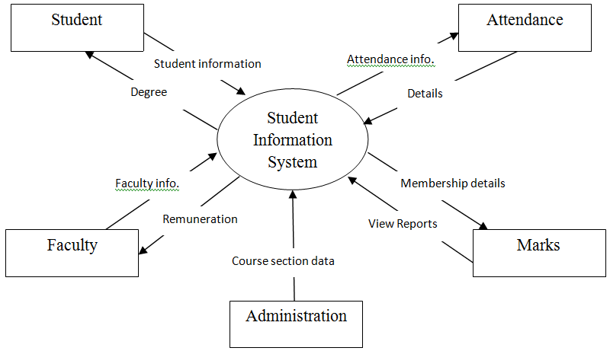

**CODE**

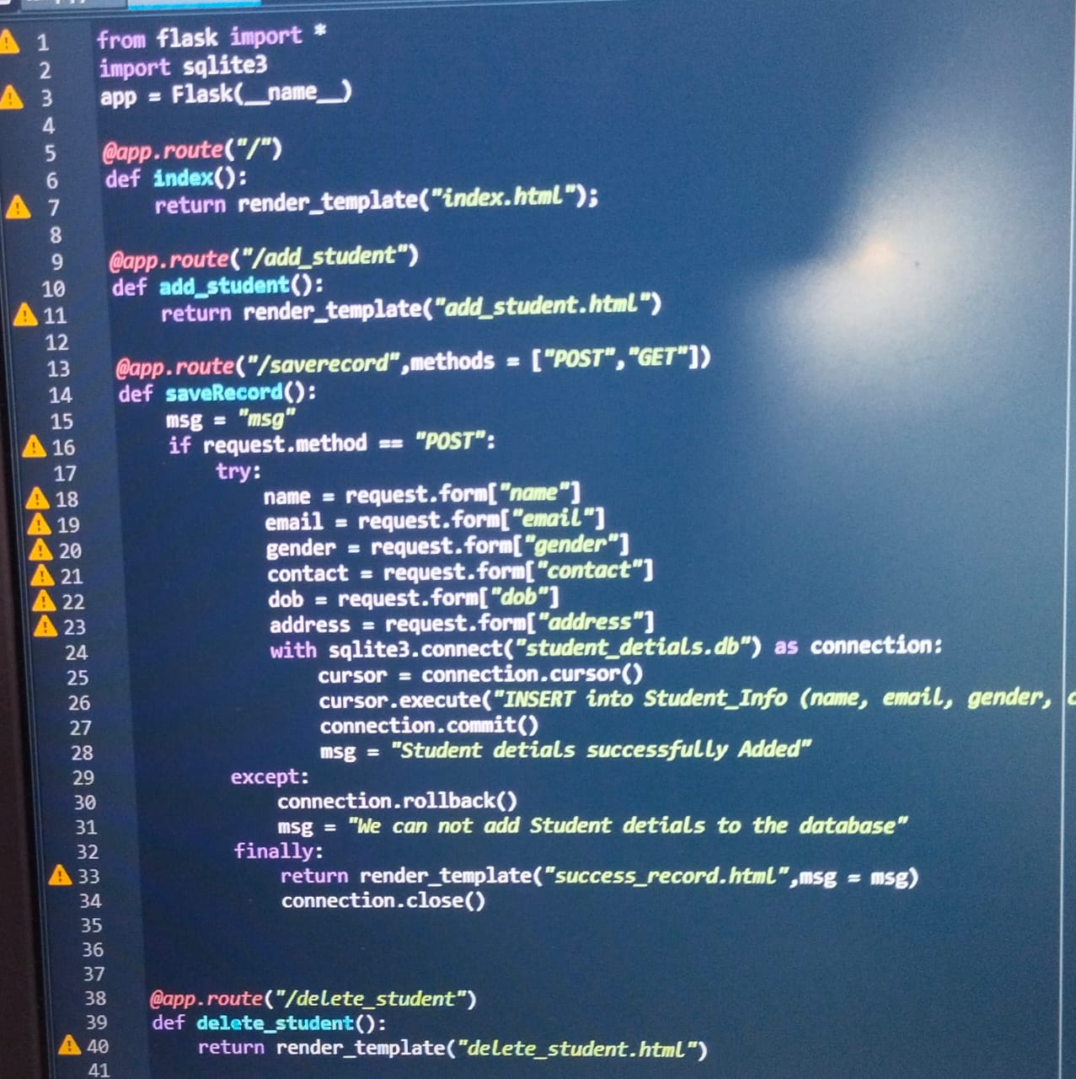

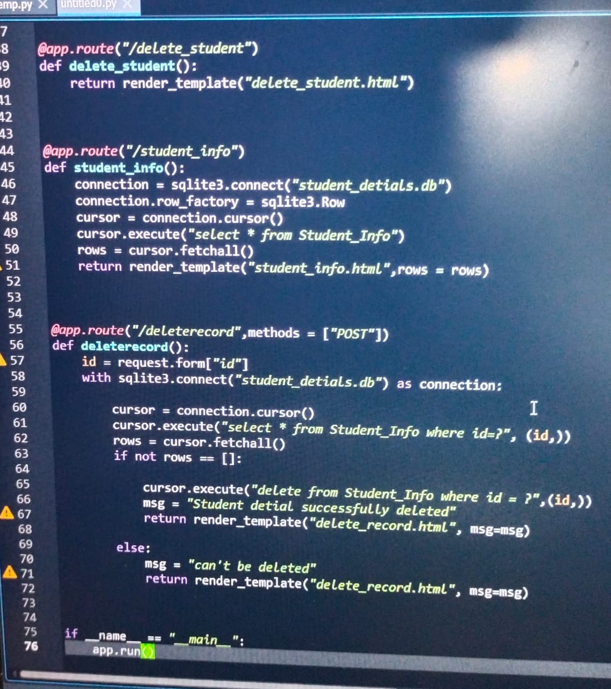

**ADVANTAGES**

* live communication with students
* simplified tools for easy course management
* incident knowledge based to guide their students
* one-stop solution to get information about very part of their employment .

CONCLUSION:

Corporate web portals are a gateway for the users to enter into the organization and gather information from a single page. KPMG has been successfully serving their employees since last twenty years through their portal. Their have been changes in the portal with time according to the demanding of the users in the organization. Its very important for the portal to the user which facilitates them through the portal easily and helps them to gather required information.